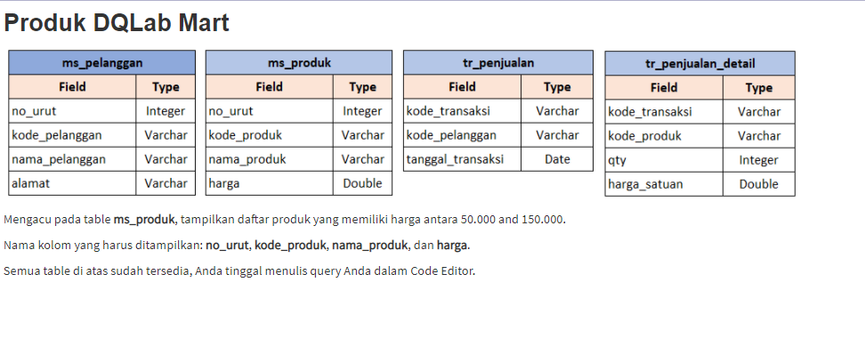

SELECT no_urut,kode_produk,nama_produk,harga FROM ms_produk WHERE harga>=50000 AND harga<=150000;

+---------+-------------+------------------------------------+--------+

| no_urut | kode_produk | nama_produk | harga |

+---------+-------------+------------------------------------+--------+

| 1 | dqp-01 | Kituk Pansel DQLub | 60500 |

| 2 | dqp-02 | Flashdisk DQLub 64 GB | 55000 |

| 3 | dqp-03 | Geft Viochar DQLub 100rb | 100000 |

| 6 | dqp-06 | Polpan Moltefonctein + Lusar DQLub | 92500 |

| 9 | dqp-09 | Boko Plunnar Agandu DQLub | 92000 |

| 10 | dqp-10 | Stecky Nitas DQLub 500 shaats | 55000 |

+---------+-------------+------------------------------------+--------+

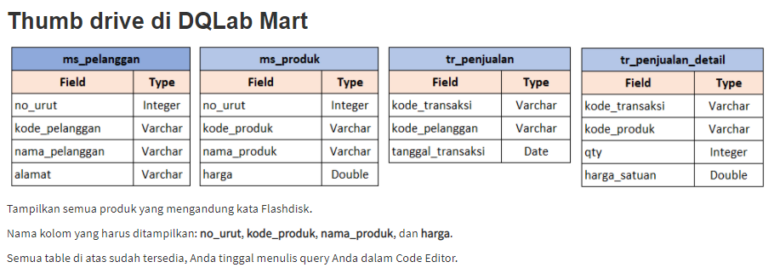

SELECT no_urut,kode_produk,nama_produk,harga FROM ms_produk WHERE nama_produk LIKE 'Flashdisk%';

+---------+-------------+-----------------------+-------+

| no_urut | kode_produk | nama_produk | harga |

+---------+-------------+-----------------------+-------+

| 2 | dqp-02 | Flashdisk DQLub 64 GB | 55000 |

| 4 | dqp-04 | Flashdisk DQLub 32 GB | 40000 |

+---------+-------------+-----------------------+-------+

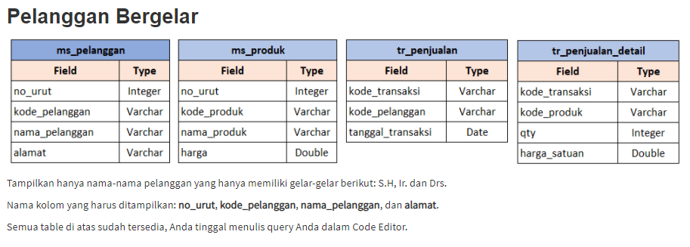

SELECT no_urut, kode_pelanggan, nama_pelanggan, alamat FROM ms_pelanggan WHERE nama_pelanggan LIKE '%S.H%' OR nama_pelanggan LIKE '%Ir.%' OR nama_pelanggan LIKE '%Drs.%';

+---------+----------------+---------------------+------------------------------------------+

| no_urut | kode_pelanggan | nama_pelanggan | alamat |

+---------+----------------+---------------------+------------------------------------------+

| 1 | dqc01 | Evu Niveunte, S.H. | Velu Sampelun, Ni. 67 - Kitu B |

| 9 | dqc09 | Ir. Agos Nogruhu | Velu Boket Sugetureos, Gung Kalupu Ni. 6 |

| 10 | dqc10 | Djiki Wurdiyi, Drs. | Velu Boket Sugetureos, Blik A1 Ni. 1 |

+---------+----------------+---------------------+------------------------------------------+

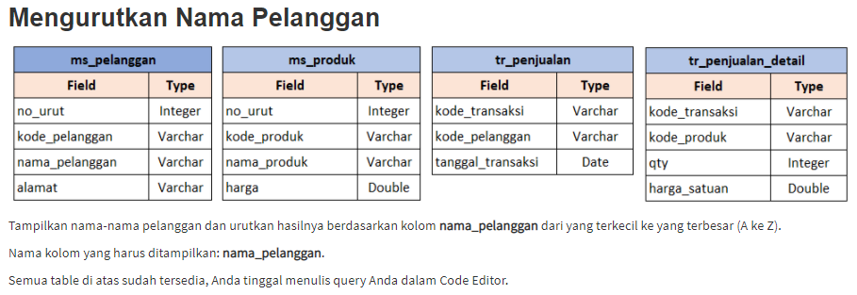

SELECT nama_pelanggan FROM ms_pelanggan ORDER BY nama_pelanggan ASC;

+---------------------+

| nama_pelanggan |

+---------------------+

| Agos Cuhyini |

| Djiki Wurdiyi, Drs. |

| Evu Niveunte, S.H. |

| Haede Gih |

| Ir. Agos Nogruhu |

| Irwun Sateunti |

| Jikilini Sokurmun |

| Mureu Reunte Seruet |

| Timmy Senugu |

| Unung Hundiki |

+---------------------+

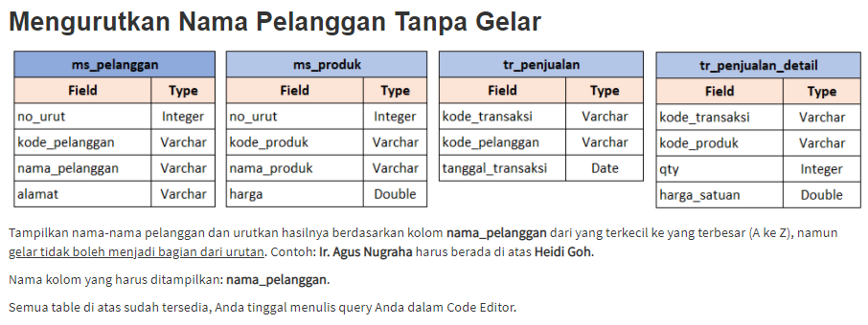

SELECT

nama_pelanggan

FROM

ms_pelanggan

ORDER BY

CASE WHEN LEFT(nama_pelanggan,3) = 'Ir.' THEN substring(nama_pelanggan,5,100) ELSE nama_pelanggan END asc;

+---------------------+

| nama_pelanggan |

+---------------------+

| Agos Cuhyini |

| Ir. Agos Nogruhu |

| Djiki Wurdiyi, Drs. |

| Evu Niveunte, S.H. |

| Haede Gih |

| Irwun Sateunti |

| Jikilini Sokurmun |

| Mureu Reunte Seruet |

| Timmy Senugu |

| Unung Hundiki |

+---------------------+

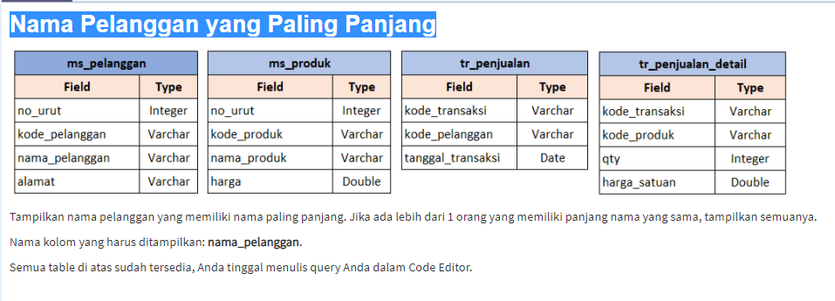

SELECT nama_pelanggan from ms_pelanggan WHERE

length(nama_pelanggan)= (select max(length(nama_pelanggan))from ms_pelanggan)

+---------------------+

| nama_pelanggan |

+---------------------+

| Mureu Reunte Seruet |

| Djiki Wurdiyi, Drs. |

+---------------------+

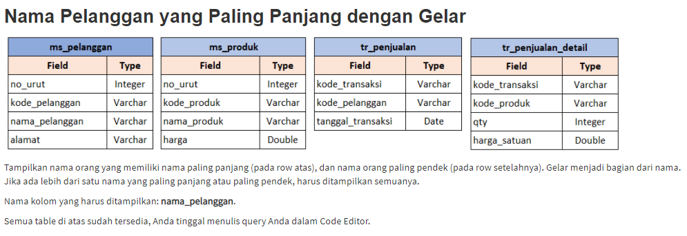

SELECT nama_pelanggan FROM ms_pelanggan

WHERE

LENGTH(nama_pelanggan) IN

(SELECT MAX(LENGTH(nama_pelanggan))FROM ms_pelanggan)

OR

LENGTH(nama_pelanggan) = (SELECT MIN(LENGTH(nama_pelanggan))

FROM ms_pelanggan)

ORDER BY

LENGTH(nama_pelanggan) DESC

+---------------------+

| nama_pelanggan |

+---------------------+

| Mureu Reunte Seruet |

| Djiki Wurdiyi, Drs. |

| Haede Gih |

+---------------------+

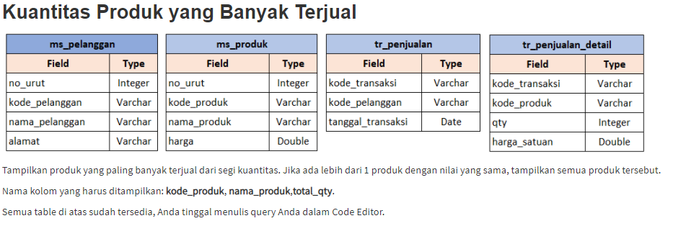

SELECT ms_produk.kode_produk, ms_produk.nama_produk, SUM(tr_penjualan_detail.qty) AS total_qty

FROM ms_produk

INNER JOIN tr_penjualan_detail ON ms_produk.kode_produk = tr_penjualan_detail.kode_produk

GROUP BY ms_produk.kode_produk, ms_produk.nama_produk

HAVING SUM(tr_penjualan_detail.qty) = (SELECT MAX(s.qty)

FROM (SELECT ms_produk.kode_produk, ms_produk.nama_produk,SUM(tr_penjualan_detail.qty)AS qty

FROM tr_penjualan_detail

INNER JOIN ms_produk ON ms_produk.kode_produk = tr_penjualan_detail.kode_produk

GROUP BY ms_produk.kode_produk, ms_produk.nama_produk)s)

+-------------+-----------------------+-----------+

| kode_produk | nama_produk | total_qty |

+-------------+-----------------------+-----------+

| dqp-04 | Flashdisk DQLub 32 GB | 7 |

| dqp-08 | Guntongun Konce DQLub | 7 |

+-------------+-----------------------+-----------+

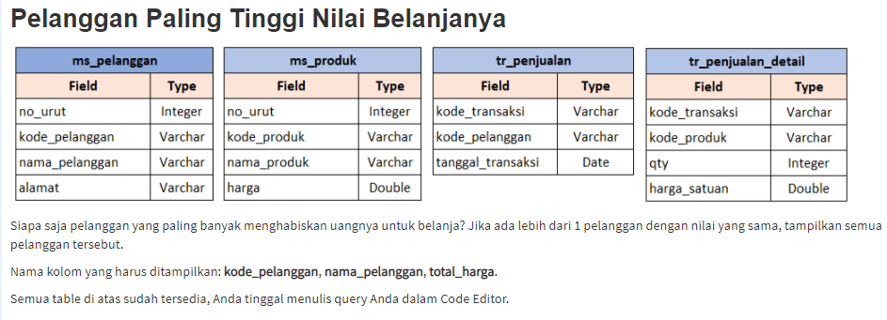

SELECT ms_pelanggan.kode_pelanggan, ms_pelanggan.nama_pelanggan, SUM(tr_penjualan_detail.qty*tr_penjualan_detail.harga_satuan) AS total_harga  
FROM tr_penjualan_detail  
INNER JOIN tr_penjualan  
ON tr_penjualan_detail.kode_transaksi = tr_penjualan.kode_transaksi  
INNER JOIN ms_pelanggan  
ON tr_penjualan.kode_pelanggan = ms_pelanggan.kode_pelanggan  
GROUP BY kode_pelanggan, nama_pelanggan  
ORDER BY SUM(tr_penjualan_detail.qty*tr_penjualan_detail.harga_satuan) DESC  
LIMIT 1;

+----------------+---------------------+-------------+

| kode_pelanggan | nama_pelanggan | total_harga |

+----------------+---------------------+-------------+

| dqc10 | Djiki Wurdiyi, Drs. | 199800 |

+----------------+---------------------+-------------+

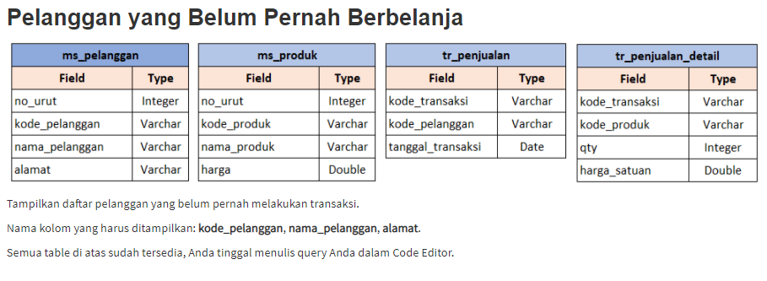

SELECT ms_pelanggan.kode_pelanggan, ms_pelanggan.nama_pelanggan, ms_pelanggan.alamat

FROM ms_pelanggan

WHERE ms_pelanggan.kode_pelanggan NOT IN (SELECT tr_penjulan.kode_pelanggan FROM tr_penjualan)

+----------------+---------------------+------------------------------------------+

| kode_pelanggan | nama_pelanggan | alamat |

+----------------+---------------------+------------------------------------------+

| dqc01 | Evu Niveunte, S.H. | Velu Sampelun, Ni. 67 - Kitu B |

| dqc07 | Agos Cuhyini | Velu Gonong Sarebo, Blik F4 - Ni. 8 |

| dqc08 | Mureu Reunte Seruet | Velu Boket Sugetureos, Gung. Suwet Ni. 3 |

+----------------+---------------------+------------------------------------------+

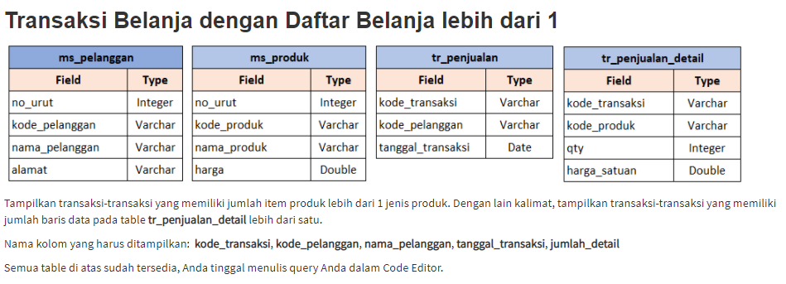

SELECT tr_penjualan.kode_transaksi, tr_penjualan.kode_pelanggan, ms_pelanggan.nama_pelanggan, tr_penjualan.tanggal_transaksi, COUNT(tr_penjualan_detail.kode_produk) as jumlah_detail

FROM tr_penjualan

INNER JOIN ms_pelanggan ON tr_penjualan.kode_pelanggan=ms_pelanggan.kode_pelanggan

INNER JOIN tr_penjualan_detail ON tr_penjualan_detail.kode_transaksi=tr_penjualan.kode_transaksi

GROUP BY tr_penjualan.kode_transaksi, tr_penjualan.kode_pelanggan, ms_pelanggan.nama_pelanggan,tr_penjualan.tanggal_transaksi

HAVING jumlah_detail > 1

+----------------+----------------+--------------------+---------------------+---------------+

| kode_transaksi | kode_pelanggan | nama_pelanggan | tanggal_transaksi | jumlah_detail |

+----------------+----------------+--------------------+---------------------+---------------+

| tr-0001 | cust0007 | Agus Cahyono | 2019-06-07 10:09:46 | 8 |

| tr-0002 | cust0001 | Eva Novianti, S.H. | 2019-06-07 13:05:12 | 3 |

| tr-0004 | cust0004 | Jokolono Sukarman | 2019-06-08 22:09:46 | 2 |

| tr-0005 | cust0003 | Unang Handoko | 2019-06-09 22:09:46 | 3 |

| tr-0006 | cust0008 | Maria Sirait | 2019-06-09 22:09:46 | 2 |

+----------------+----------------+--------------------+---------------------+---------------+